**Round Robin Assignment Using Trigger and WorkFlow Rule**

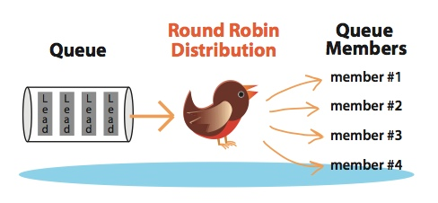

***In this tutorial we will assign cases using RRD for example purpose.***

**Step 1 - Round Robin Assignment using Workflow Rule: -** Use WorkFlow rule for RRD whenever you know the number of users you need to distribute LEAD/CASE for example 3, 4, 5 users. For limited users Salesforce has already published an article and you can give it a try here [**How do I create a round-robin assignment for Leads or Cases to users?**](https://help.salesforce.com/articleView?id=000004000&type=1)

But in most of the cases we do not know how many users and queues will be involved to which we want to distribute the CASE?LEAD to this scenario I have written a custom solution read step 2.

**Step 2:- Round Robin Assignment using Triggers: -**  If you do not aware that how many users will be there in queue then you need to write a custom logic using trigger.

Prerequisites: - 1) Basic Understanding of Apex

2) Basic Understanding of Workflow Rule

3) Basic Understanding of Queues.

1. Create a Queue and add users to that queue. **Setup -> Administer -> Manage Users -> Queues ->** New and enter Label, Queue Name, Select Object for example Case and Select users that you wanted to Add.

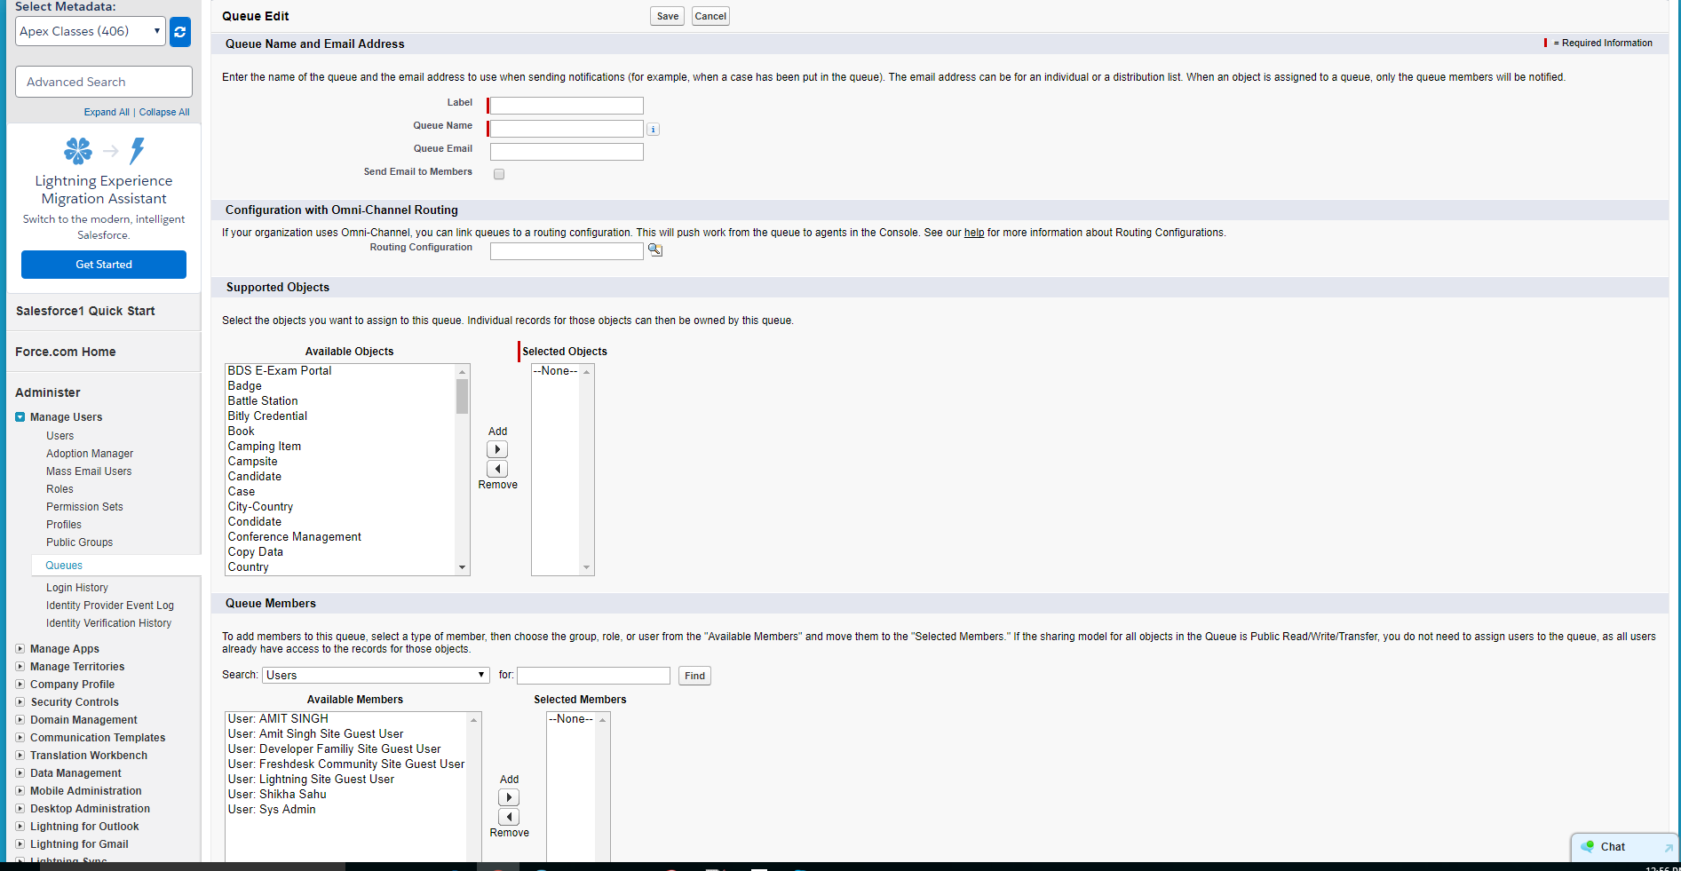

1. **Create a Workflow rule:-** In this step we will create a WFR which will update the case **owner to the Queue** that we have created. **Setup -> Create Workflow & Approval Process -> Workflow Rules -> New Rule -> Case ->** see screenshot below. **(You can also create the same workflow into LEAD object case is used for an example)**

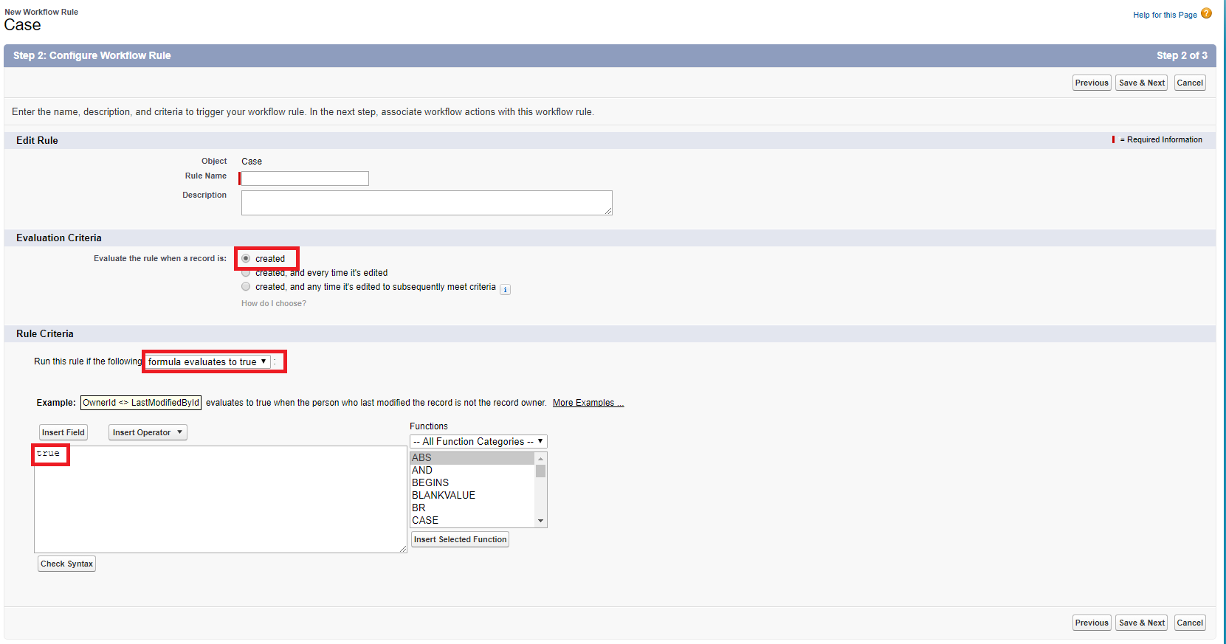

For Workflow Action Select **New Field Update** and change the Owner to the Queue that we have created earlier. **Click on Save and then Click on Done and activate the workflow.**

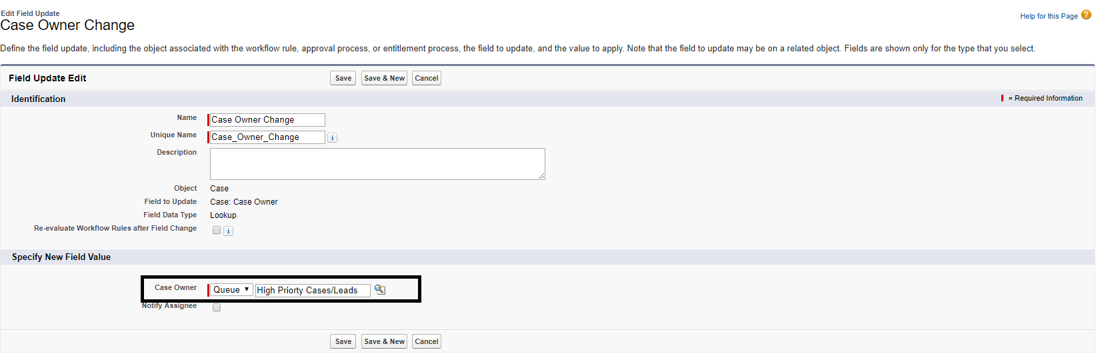

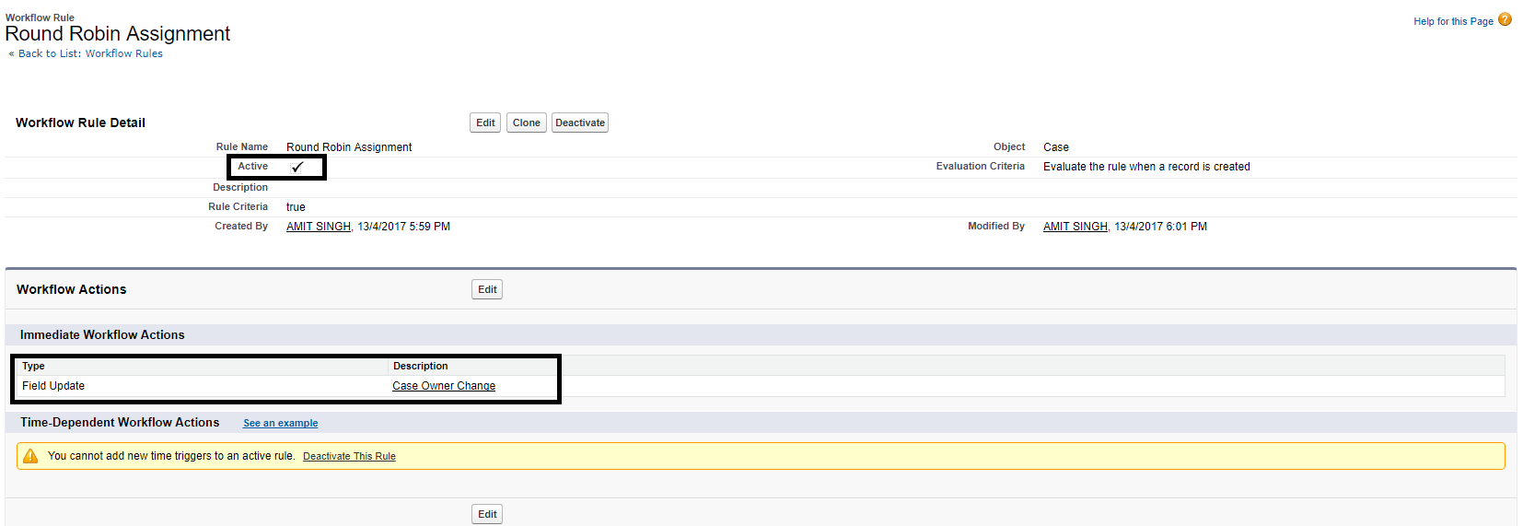

3 - Create a new custom Autonumber field into Case/Lead Object. **Setup -> Customize -> Cases -> fields ->** scroll down to “**Case Custom Fields & Relationships**” section and click on new button. Data Type Select **AutoNumber Click next** Enter field Label like **Case #** and display format(**Case-{0000}**), starting number(1) and check **“Generate Auto Number for existing records”** checkbox if you want to generate auto number for existing case/leads other wise leave it blank. **Next, Next and do not add this field into Layout and Click on Save**.

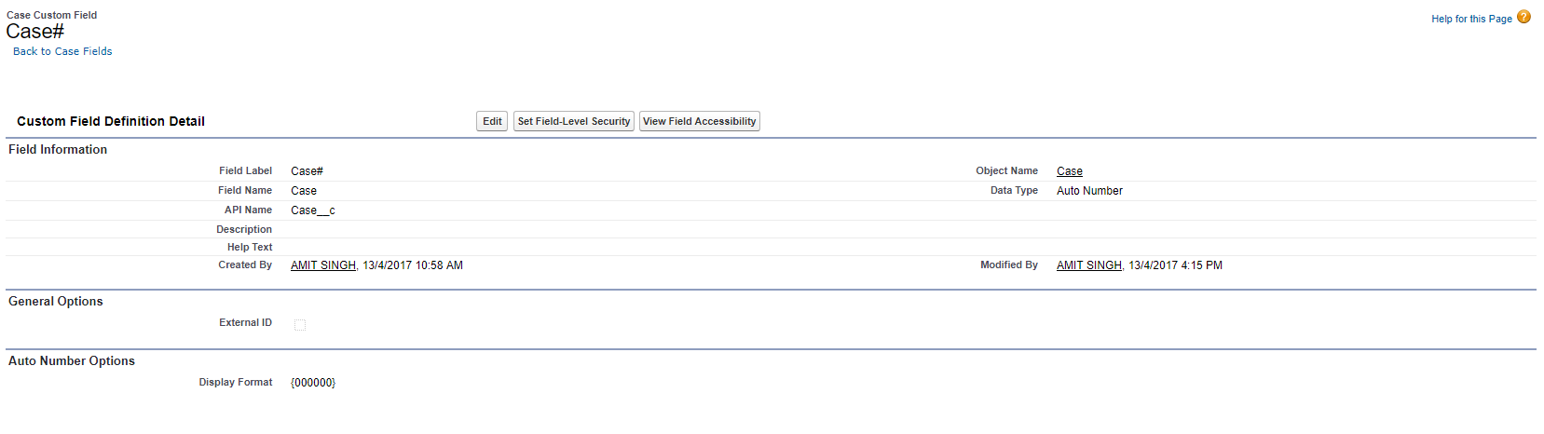

**4- Create Apex class and Apex Trigger:-**  Here we are, we are done with configuration part and in this step we will create a trigger and it’s handler class which be responsible for assigning the cases/leads using Round Robin Algo.

1. **Setup -> Develop -> Apex Classes -> New ->** and paste the below code.

public class caseRoundRobinAssignment{

public static Boolean runOnce = false;

public static Boolean runMerge = false;

public static void assignTicketsRoundRobin(Set<Id> ticketIdsSet){

/* get list of all the tickets */

List<Case> ticketList = [Select Id, OwnerId, Case__c FROM Case Where Id IN:ticketIdsSet];

Integer index;

Integer ticketNumber;

Integer agentSize;

List<User> agentList = new List<User>();

Set<Id> queueIdsSet = new Set<Id>();

System.debug('#### ticketList = '+ticketList);

// Fetch Ids of the group.

For(Case c : ticketList){

If(String.valueOf(c.ownerId).startsWith('00G')){

queueIdsSet.add(c.ownerId);

}

}

// return if Case is already assigned to user

If(queueIdsSet==null || queueIdsSet.size()==0)return;

System.debug('#### queueIdsSet = '+queueIdsSet);

Set<Id> userIdsSet = new Set<Id>();

// Fetch Ids of the users

For(GroupMember gm : [Select Id, UserOrGroupId FROM GROUPMEMBER WHERE GroupId IN : queueIdsSet]){

userIdsSet.add(gm.UserOrGroupId);

}

System.debug('#### userIdsSet = '+userIdsSet);

/* fetch the total no of users for RRD that are active */

agentList = [Select Id, Name, Profile.Name From User Where Id In : userIdsSet AND ISACTIVE = true];

// return if there are no active users

If(agentList==null || agentList.size()==0)return;

System.debug('#### agentList = '+agentList);

For(Case c : ticketList){

if(c.Case__c!=null){

ticketNumber = Integer.valueOf(c.Case__c);

System.debug('#### ticketNumber = '+ticketNumber);

agentSize = agentList.size();

index = Math.MOD(ticketNumber ,agentSize);//+1;

System.debug('#### index = '+index);

c.OwnerId = agentList[index].id;

}

}

If(ticketList!=null && ticketList.size()>0){

System.debug('#### Updating tickets = '+ticketList);

update ticketList;

}

}

}

1. Setup -> Customize -> Cases -> Case Triggers -> and paste the below code.

trigger case_Trigger on Case (After Update) {

caseRoundRobinAssignment.assignTicketsRoundRobin(Trigger.NewMap.keySet());

}

**Now in the final step test the functionality by creating multiple cases and cases will be assigned to those users that are available into queues using Round Robin Algo.**

**Hope this blog was helpful to you.**